
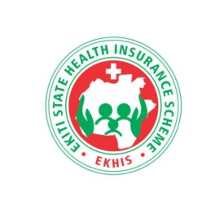

EKHIS 2023 Annual Report
REPORT OF ACHIEVEMENTS FOR THE YEAR 2023

Ekiti State Health Insurance Scheme
Telephone : 234 8033203314
E-mail : ekhis@ekitistate.gov.ng

Forward

As we turn the pages of this annual report, we embark on a journey through the corridors of healthcare, traversing the landscape of wellness and resilience. It is my distinct pleasure to introduce this comprehensive documentation of our Health Insurance Scheme's endeavors, achievements, and impact over the past year.
The State Government under the leadership of HE Mr. Biodun Abayomi Oyebanji through the Ekiti State Health Insurance Scheme stands as a beacon of assurance amidst uncertainty, offering accessible and reliable healthcare services to individuals and families, ensuring that health concerns need not translate into financial burdens.
This report serves not only as a reflection of our achievements but also as a testament to our unwavering commitment to the health and well-being of our beneficiaries. From expanding coverage to introducing innovative services, each page tells a story of dedication, innovation, and above all, compassion.
Throughout the pages that follow, you will find evidence of our ongoing efforts to enhance accessibility, improve quality, and promote preventive care. Whether it be through partnerships with healthcare providers, implementation of digital solutions, or proactive community outreach programs, our aim remains singular: to empower individuals to lead healthier, more fulfilling lives.
I extend my deepest gratitude to all those who have contributed to the success of Ekiti State Health Insurance Scheme – from the dedicated staff and healthcare partners to the individuals and families who place their trust in us. It is through your collective efforts that we continue to make a meaningful difference in the lives of countless individuals, each and every day.
As we look towards the future with optimism and resolve, may this report inspire us to redouble our efforts, to embrace innovation, and to remain steadfast in our pursuit of a healthier, more equitable world for all in Ekiti State

Dr. Oyebanji Filani
Hon. Commisioner for Health and Human Services
Ekiti State

From The General Manager

Dr. Charles, DOHERTY ( General Manager)

As we reflect on the past year, it is with great pride and a sense of responsibility that we present the annual report for our Agency. In the face of unprecedented challenges and uncertainties, our commitment to ensuring accessible and affordable healthcare for all remains unwavering.
The past year was marked by inadequate fund for operations and programmes of the Scheme. In the midst of these challenges, our Agency has stood as a beacon of hope, providing essential healthcare coverage to our citizens when they needed it the most.
Through the dedication and hard work of our healthcare professionals, administrators, and partners, we have made significant strides in expanding access to quality healthcare services across our state. From rural communities to urban centers, our scheme has reached thousands of individuals and families, providing them with the peace of mind that comes with knowing they are protected against the financial burden of illness and injury.
Our commitment to innovation and continuous improvement has been central to our success. We have leveraged technology to streamline processes, enhance efficiency, and improve the overall user experience for our beneficiaries. By embracing digital solutions and harnessing data-driven insights, we have been able to better understand the needs of our population and tailor our services accordingly.

As we look ahead, we recognize that there is still much work to be done. The health needs of our population are constantly evolving, and we must remain agile and responsive in our approach. We must continue to identify and address gaps in coverage, improve the quality of care, and strengthen our partnerships with healthcare providers and stakeholders.
At the heart of our Agency is a commitment to equity and social justice. We believe that access to healthcare is a fundamental human right, and we remain steadfast in our commitment to ensuring that no one is left behind.

In closing, I would like to express my sincere gratitude to the government of HE. Mr. Biodun Abayomi Oyebanji for His strong commitment to the health sector and wellbeing of Ekiti citizens. Also, I commend the the support of the Honourable Commissioner for Health and Human Services, Dr. Oyebanji Filani and all those who have contributed to the success of our Ekiti State Health Insurance Scheme. Your dedication, passion, and tireless efforts have made a tangible difference in the lives of our citizens, and for that, we are truly grateful.
Together, let us continue to build a healthier, more prosperous future for all.

Dr. Charles Doherty
General Manager

Ekiti State Health Insurance Scheme Structure
EKHIS Organogram

EKHIS Committee
Claims verification
Software maintenance
Hardware & Software
Final Account
Treasury
Disbursement
Advocacy & Sensitization
Enrollment
Accreditation
Call centre
Authorization code
Social Mobilization
Internal Audit
ICT
Finance & Account
M&E
plans & budget
Programme
Standard Quality Assurance
Gen . Admin
HR
store
Planning, Research & Statistics
Admin & Supply
General Manager
ICT
Social Mobilization
Internal Audit
final acct.
Hardware
Software
HMIS
Research &Publications
Trainning
Ekiti State Health Insurance Scheme Top Management as at December, 2023

Dr. Doherty Charles, GM
Mrs. Aregbesola Gbemisola
Head of ICT
Mr. Akinola Ilesanmi
Auditor
Mrs. Oyediran Prscilla
Director, Quality Assurance
Mr. Ogundero Oluwagbenga
Director, Program
Mr. Ogunyemi Oyeyemi, DPRS
Director, Planning Research & Statistics
Mr. Olaoye Samuel
Director, Finance and Account
Mrs. Adeyemo Grace
Director, Admin and Supplies

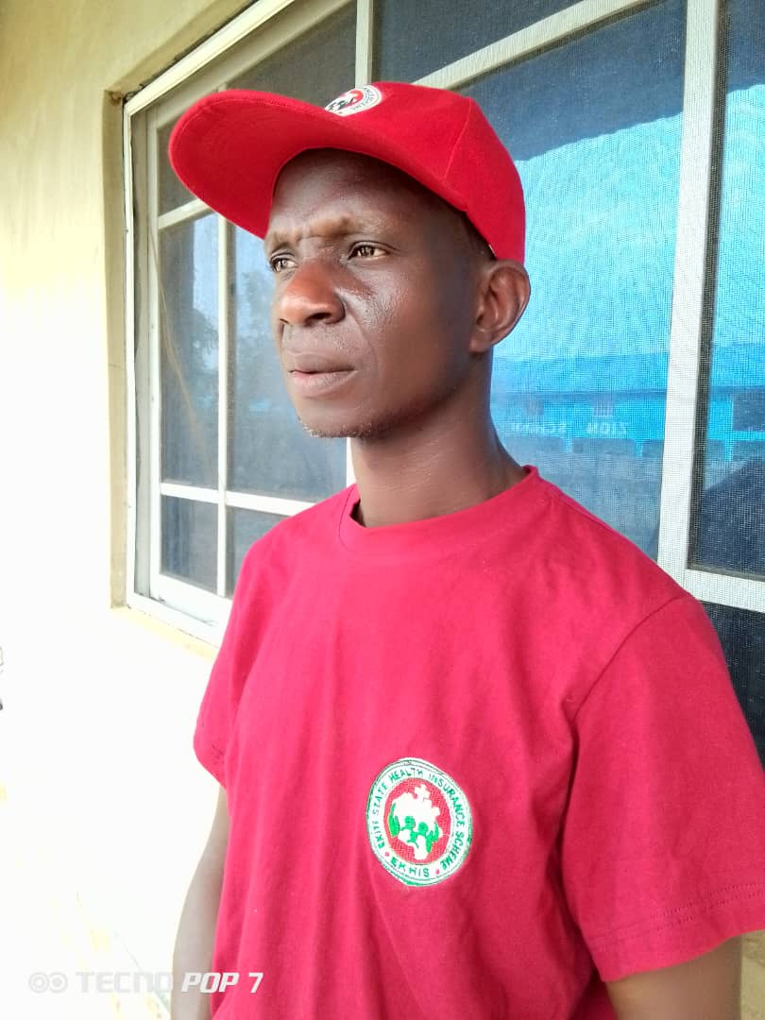
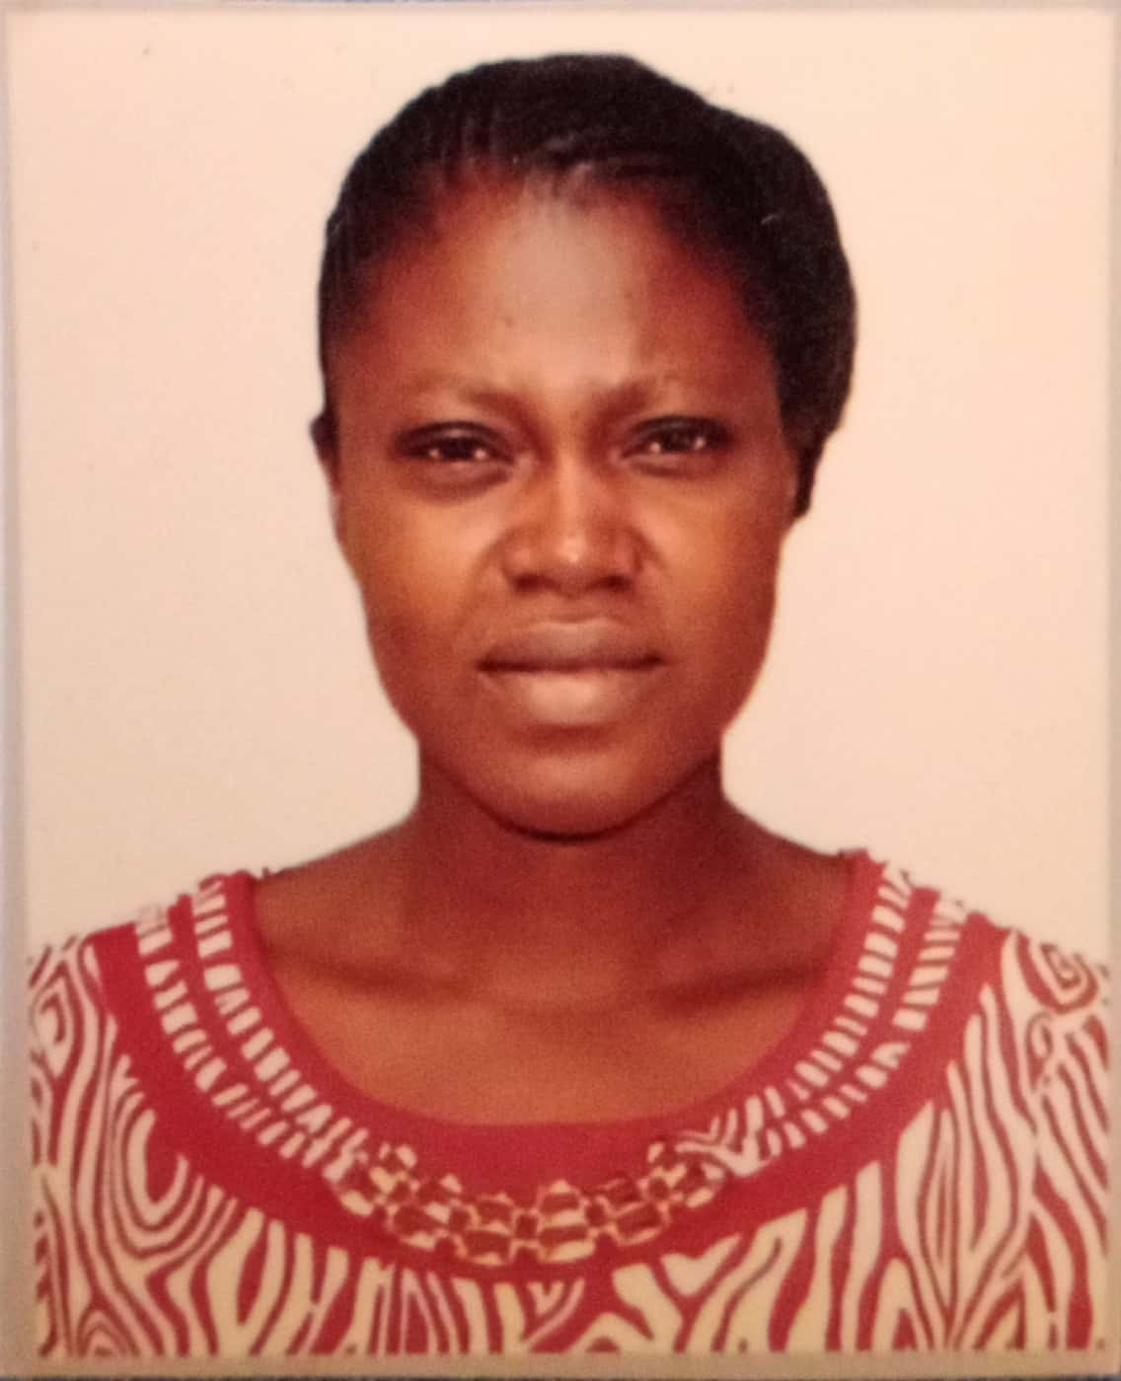
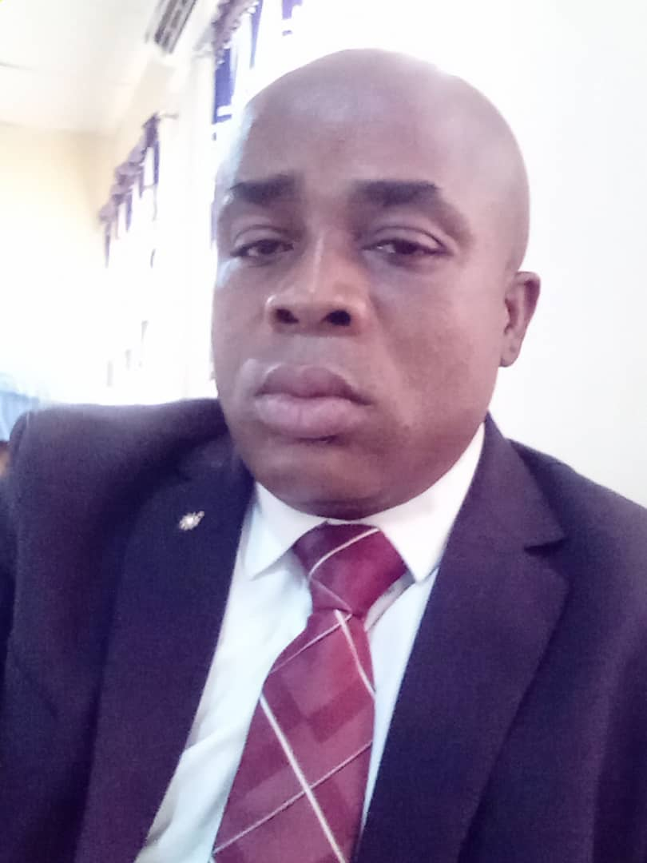
81


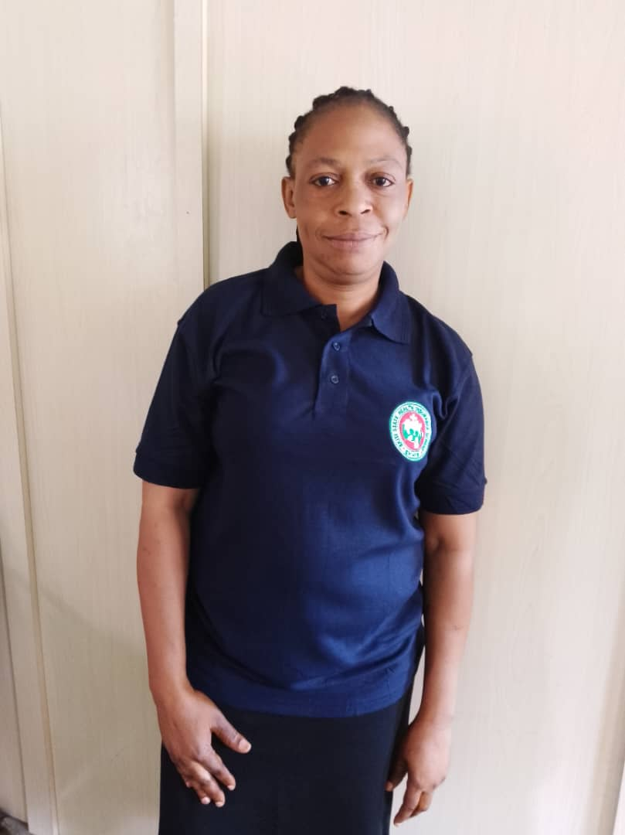
Ekiti State Health Insurance Scheme (EKHIS) Management Team

S/N | Name | Department | Designation
1 | Dr Charles Doherty | Office of the General Manager | General Manager
2 | Mrs. Adeyemo Grace | Admin & Supplies | Director
3 | Mr. Olaoye Samuel | Finance and Account | Director
4. | Mr. Ogundero Oluwagbenga | Program | Director
5 | Ogunyemi Oyeyemi | Planning, Research and Statistics | Director
6 | Mrs. Oyediran Priscilla | Quality Assurance | Director
7 | Mr. Ilesanmi Akinola | Central Internal Audit | Auditor
8 | Mrs. Aregbesola Gbemisola | Information and Communication Technology | Head

S/N | Category | Number
1 | Senior Staff | 24
2 | Junior Staff | 3
Total number of staff |  | 27

ACRONYMS
ABUAD Afe Babalola University, Ado- Ekiti
AIDS Acquired Immune Deficiency Syndrome
ANC Antenatal Care
AOP Annual Operational Plan
BHCPF Basic Healthcare Provision Fund
CBOs Community Based Organizations
CHAI Clinton Health Access Initiative
CHEWS Community Health Extension Workers
CSOs Civil Society Organizations
DMA Drug Management Agency
DRF Drug Revolving Funds
EDL Essential Drug List
EKHIS Ekiti State Health Insurance Scheme
EKSUTH Ekiti State University Teaching Hospital
EMS Emergency Medical Services
ESHMB Ekiti State Hospitals Management Board
ESPHCDA Ekiti State Primary Health Care Development Agency
FETHI Federal Teaching Hospital Ido-Ekiti
FGM Female Genital Mutilation
FMOH Federal Ministry of Health
FP Family Planning
GBV Gender Based Violence
HCFE Health Care Financing Expenditure
HCW Health Care Worker
HFs Health Facilities
HMIS Health Management Information System
ICT Information and Communication Technologies
LGA Local Government Area
M&E Monitoring and Evaluation
MCH Maternal and Child Health
MDGs Millennium Development Goals
NEMA National Emergency Management Agency
NGO Non-Governmental Organization
NH Act National Health Act
NHIA National Health Insurance Authority
NHMIS National Health Management Information System
NMEP National Malaria Elimination Programme
NPHCDA National Primary Health Care Development Agency
OIC Officer in Charge
PHC Primary Health Care
PHCUOR Primary Health Care Under One Roof
QA Quality Assurance
QC Quality Control
SACA State Agency for the Control of AIDS
SMoHHS State Ministry of Health and Human services
SOMLPforR Saving One Million Lives Programme for Result
WDC Ward Development Committee
WHO World Health Organization

Executive Summary
The Ekiti State Health Insurance Scheme's yearly report provides a comprehensive overview of the Scheme’s performance, challenges, and achievements over the past fiscal year. In Year 2023, the scheme continued its commitment to providing accessible and affordable health coverage to our beneficiaries while striving for excellence in service delivery and financial sustainability.
Key Highlights
Utilization Growth
Throughout the fiscal year, the scheme witnessed a steady increase in utilization, reflecting the growing trust and confidence of individuals and families in our coverage. The total number of beneficiaries utilized services under the scheme reached 139,260, marking a 500% increase from the previous year.
Expanded Coverage
Our commitment to expanding coverage led to the expansion of ULERAWA programme to all the 177 accredited facilities in the state. This expansion ensured that beneficiaries have access to a wide range of medical treatments, enhancing their overall healthcare experience.
Financial Performance
Despite economic challenges and evolving healthcare landscapes, the scheme maintained a robust financial position. Through prudent financial management officers, we sustained adequate reserves to meet future obligations while ensuring that enrollees access quality health care services.
Quality Improvement Initiatives
Continuous quality improvement remained a focal point of our operations. We implemented measures to enhance the quality of care provided by health care providers, streamline claims processing, and improve member satisfaction through feedback mechanisms and grievance redress procedures.
Information and Communication Technology
We invested in innovative solutions to streamline administrative processes, improve data management, and improve medical errors. These efforts resulted in greater efficiency, transparency, and accessibility across the scheme. for their unwavering support and dedication to our shared vision of a healthier, more resilient future.
Rising Healthcare Costs
The persistent challenge of escalating healthcare costs necessitates ongoing efforts to balance affordability with quality care. We remain vigilant in managing costs while exploring innovative strategies to contain expenses without compromising on healthcare outcomes.
Looking Ahead
As we reflect on the achievements and challenges of the past year, we remain steadfast in our commitment to advancing the mission of the Ekiti State Health Insurance Scheme. In the year ahead, we will focus on innovation, collaboration, and sustainability to further enhance the value proposition for our members, providers, and stakeholders.
Through proactive engagement, strategic partnerships, and a relentless pursuit of excellence, we aspire to strengthen the foundation of the scheme, ensuring that it remains a cornerstone of healthcare financing and access for generations to come.
We extend our gratitude to all stakeholders for their unwavering support and dedication to our shared vision of a healthier, more resilient future.

Ⅱ

Chapter one: Introduction
Ekiti State Government signed into law the bill establishing the Ekiti State Health Insurance Scheme (EKSHIS) in 2016, with the objective of providing equitable access to basic healthcare needs and risk protection for the residents regardless of income levels or social status. This objective aligns with the United Nation Sustainable Development Goal on healthcare (SDG3) of ensuring healthy lives and promoting well-being for all while strengthening the health systems.
Objectives;
The Scheme’s objectives are to;
- Ensure access to quality health care services for every resident of Ekiti State
- Ensure residents have financial protection and access to affordable health care services
- Protect families from the financial hardship of huge medical bills
- Limit the cost inflation of healthcare services
- Ensure the Basic Minimum Package of Health Services (BMPHS) as stipulated by the National Health Act is delivered to the poor and vulnerable residents of Ekiti State
- Ensure equitable distribution of healthcare costs across income groups
- Promote efficiency in healthcare service delivery
- Promote private sector participation in the provision of healthcare services
- Ensure adequate distribution of health facilities within the state
- Develop alternative funding mechanisms to enhance delivery of health services
- Take necessary measures to facilitate access and delivery of quality health services for all residents of Ekiti State
Health Plans
The Ekiti State Health Insurance Scheme has the following health;
Ekiti State Equity Health Plan (EKEHP)
Community Based Health Plan (CBHP)
Ekiti State Private Health Plan (PHP)
Formal Health Plan (FHP)
Map of Ekiti State showing Local Government Areas coverage for EKHIS
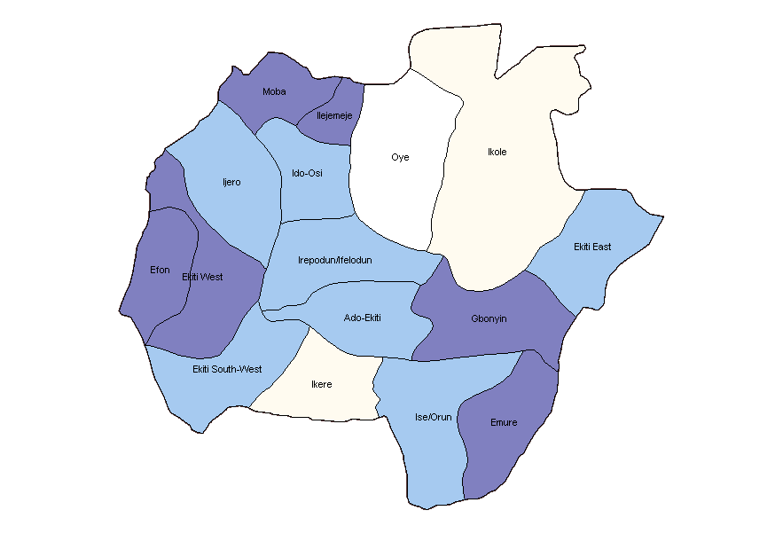

1.1 Mandate of Ekiti State Health Insurance Scheme.
The mandates of EKHIS include the following:
- Implementation of the minimum benefit package as defined Under the National Health Act;
- Registering NHIS accredited Health Maintenance Organizations and or Mutual Health Associations, state accredited healthcare facilities and other relevant institutions;
- Classifying healthcare facilities and providers in a manner that shall help improve health outcomes in the state as required under the National Health Act;
- Determining the percentage of the premiums from private health plans that shall be payable as cross subsidy to the fund for the purpose of financing the Health Equity Plan for the poor and vulnerable;
- Approving format of contracts for the HMOs and all health care providers;
- Carrying out public awareness and education on the establishment and management of the health Scheme;
- Promoting the development of Mutual Health Associations for wider participation in the scheme;
- Coordinating research and statistics;
- Establishing quality assurance for all stakeholders;
- Ensuring manpower development in the Scheme;

Chapter Two: Activities and Achievements of various Departments

2.1 Department of Planning, Research and Statistics

Mr. Oyeyemi, OGUNYEMI (Director)

2.1.1 Introduction
The Department of Planning, Research, and Statistics in Ekiti State Health Insurance Scheme has been instrumental in providing valuable insights and data-driven solutions to improve the healthcare services. This report aims to highlight the key achievements, challenges, and future plans of the department over the past year.
2.1.2 Key Achievements in year 2023
Data Collection and Analysis
The department successfully collected, validated and analyzed a wide range of BHCPF and UILERAWA data, including demographic trends, disease prevalence, healthcare utilization, and patient outcomes. This data has been crucial in informing evidence-based decision-making and policy formulation.
2.1.2.1 Research Initiatives
The department initiated several data for research projects aimed at addressing pressing health issues. Our data have been used by CHAI, SYDANI group and individuals from ABUAD for research purposes. The findings from these research endeavors have contributed to the development of targeted interventions and programs.
2.1.2.2 Strategic Planning
The department actively participated in the development of strategic plans in the state for improving healthcare delivery, resource allocation, and infrastructure development. This has helped in aligning the healthcare system with the evolving needs of the population.

2.1.2.3 Collaboration and Partnerships
The department fostered collaborations with other healthcare organizations, such as MOH&HS, HMB, SPHCDA research institutions, and government agencies to leverage expertise and resources for the betterment of public health.
2.1.2.4 Monitoring and Evaluation
The department successfully conducted Monitoring and Evaluation to all the 16 LGAs in the State and the report have been circulated to the necessary stakeholders which has aided prompt decision making.
2.1.2.5 Proposals writing
The department also developed proposals for various procurement.
2.1.2.6 Capacity Building
The department participated in various capacity building in the agency which include: Gender Mainstreaming, leadership development, stakeholder Engagement and Team Management, Future of Health System Program for Leaders and Financial Management.
2.1.2.7 Stakeholder Engagement
The department participated in community sensitization and medical outreaches to Oye, Ikole, Ise/Orun and Ido/Osi LGAs to improve the enrollment and utilization of health insurance programmes in Ekiti State.
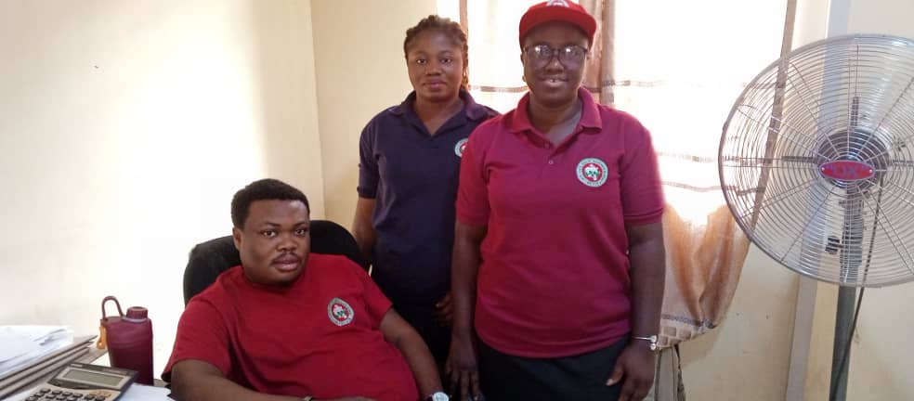
Department of Planning, Research and Statistics Staff

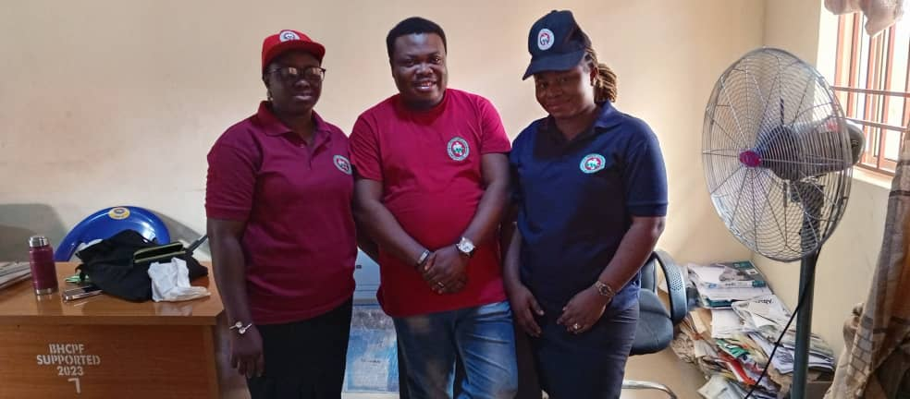
Department of Planning, Research and Statistics Staff, The Director; Ogunyemi Oyeyemi (Centre)

2.2 Department of Quality Assurance
Mrs. Priscilla, OYEDIRAN (Director)

2.2.1 Mandate of the Department
The Department of Standard Quality Assurance is responsible for ensuring that all services provided under the scheme are in compliance with guidelines for the provision of such services as provided in the national guidelines or services protocols.
It involves assessing or evaluating quality, identifying problems or issues with care delivery and follow up monitoring to make sure the activities did what they were supposed to.
Achievement for the year 2023
- Improve Quality of care at the primary and secondary health care level through our continuous data quality assurance assessment.
- The call center on Basic health care provision fund received and responded to 23,000 calls and provided information on BHCPF from Jan-Dec.
- The call center received total of Two thousand and four hundred (2040) calls on different complaints and enquiries from Sept-Dec 2023.All the calls were attended to accordingly and properly documented.
- Increased coverage by engaging some selected private Hospital for effective maternal and child health services.
- The Quality Assurance department issued four hundred and seventy (470) referral codes in the Local Government Area. The quality assurance department refer from primary level to the secondary level and tertiary level of health care. i.e from PHC TO SHC.
- The quality assurance department go for quarterly sensitization to ensure quality care is being render to patients in each local government area.

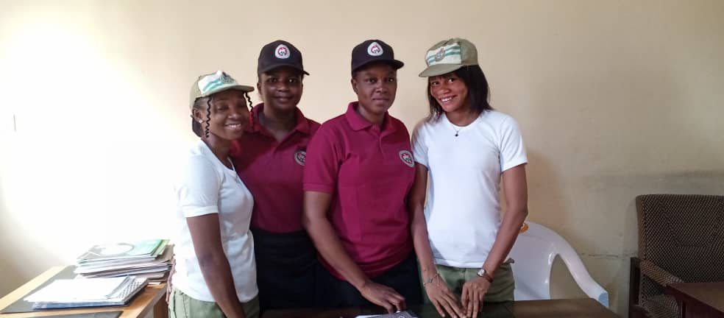

Quality Assurance Team

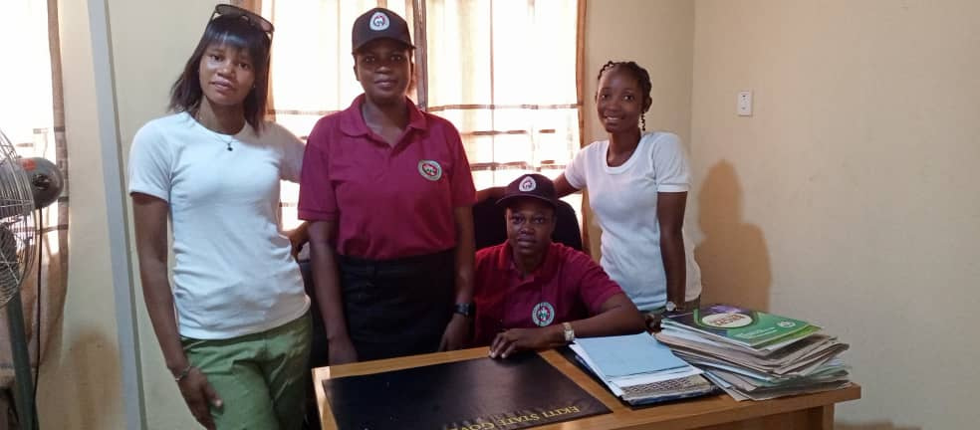

Quality Assurance Team, sitting down is the Director; Mrs. Priscilla Oyediran
2.3 Department of Program
MLS. Oluwagbenga, OGUNDERO (Director)

2.3.1 INTRODUCTION
Ekiti State Health Insurance promotes Statewide health coverage, ensuring that everyone has access to affordable and quality healthcare services when needed. It covers medical expenses including preventive services, treatments, medications and hospitalizations. The services are rendered under Equity Health programme which are BHCPF and Ulerawa.

2.3.2 MANDATE:
Programme as a department under the EKHIS is saddled with the following responsibilities.
- Advocacy visit / Sensitization and Community Mobilization of masses within the Community for Health Insurance.
- Training of Health Workers and other implementation Stakeholders
- Enrolment of Beneficiaries for Health Insurance Continuous
- Medical Outreach to the Vulnerable people across the 16 LGAs
- Oversight roles on Health insurance activities within and outside the scheme.
2.3.3 ACHIEVEMENTS
- Beneficiaries were enrolled into BHCPF from the following groups.
i. Pregnant women
ii. Children Under five years.
iii. Poorest of the Poor
Iv. Elderly
v. Women of Child bearing age (15-49yrs).
vi. Sickles-cell warriors
vii. People living with Human Immuno-deficiencies Virus ( PLWHIV)
viii. WAOH ( Widow & orphans)
ix. LIWOM
X. People with Disabilities (PWD)
Xi. Pensioners. e.t.c
- Supervisory Roles in ensuring the Capturing of beneficiaries for Ulerawa programme for the following groups:
i) Pregnant women
ii) Children under five years
v) Others for Malaria
- Training of Health Care Providers on Equity Health Program (BHCPF and Ulerawa)
a. Primary Health Care Facilities and Agencies
b. Secondary Healthcare Facilities and Management Board.
- Community Sensitization: Medical Outreach to the underlisted Local Government Areas.
- Ido/Osi
- Oye
- Ikole
- Ise and others
- Advocacy visits to:
i. State Stakeholders on Health
ii. Local Government Areas Stakeholders on Health
iii. Some Ministries and Parastatals
- Mentoring on Primary Health Care givers on BHCPF and Ulerawa
- Oversight Function on Enrollees Verification under BHCPF for bio-data authentication.

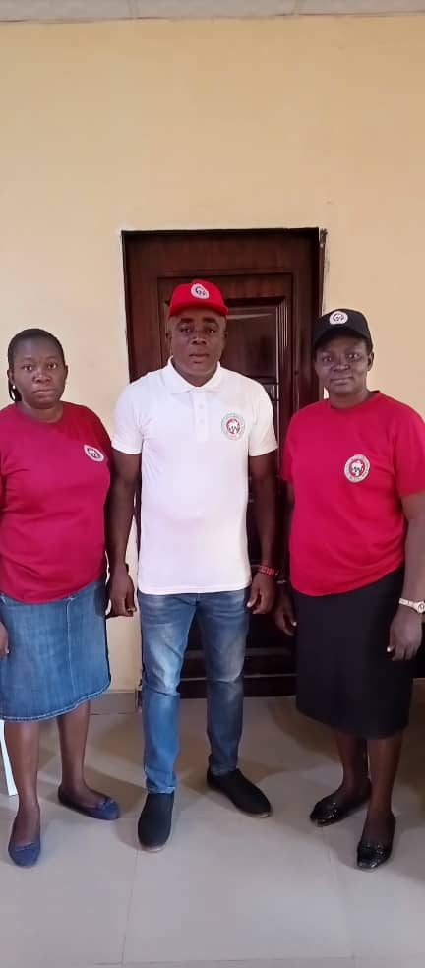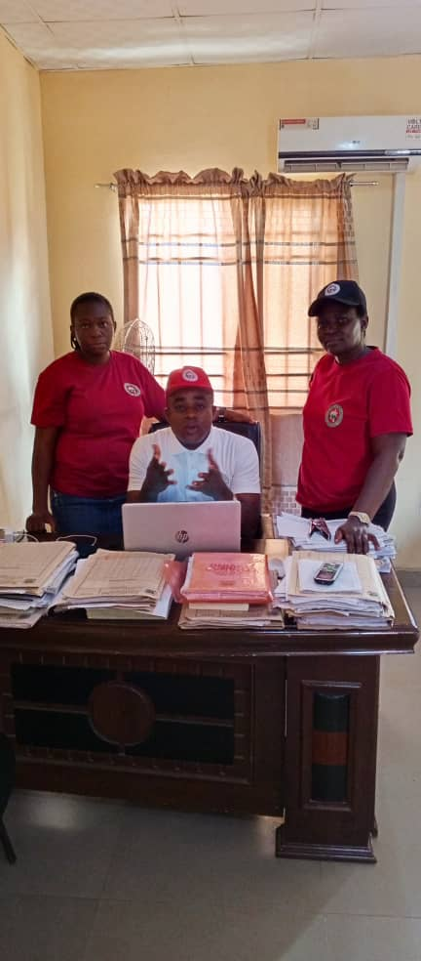

Department of Program Staff, The director; MLS. Ogundero Oluwagbenga (Centre)

2.4 Department of Admin and Supply
Mrs. Grace, ADEYEMO (Director)

2.4.1 Introduction
The Department of Administration and Supplies provides routine assistance by ensuring that matters affecting the office and staff are handed and processed in accordance with the provision of the Civil Service rules.
2.4.2 Functions
The Functions of the Department mainly centre on the efficient and effective management of both human and material resources which include:
- Handing staff matters such as promotions, Discipline, Appointments.
- Processing Applications for Secondment, Transfers Conversions of Staff.
- General Maintenance of Equipment, Furniture and provisions of other related utility services for better service delivery.
- Organizing Training Programmes for staff
- Making purchases on behalf of the office
ACHIEVEMENT OF ADMIN & SUPPLIES
S/N | DATE/MONTHS | ITEMS | QUANTITIES
1 | 6/3/2023 | Tables and chairs, standing ox fan plastic chair was purchased and delivered. | 10 tables, 20 chairs and 12 plastic chairs and 4 ox fans.
2 | 13/3/2023 | Procurement of Galaxy Tab. 25pcs.  Samsung Galaxy for all facilities. | 25 pcs.
3 | 21/6/2023 | Public address system and projector was purchased and delivered. | 1 public address system  1 projector
4 | 13/7/2023 | Laserjet Pz 035 printer was purchased and delivered | 3
5 | 21/8/2023 | Spark 10c (4+128) was purchased and delivered to contact the enrollees. | 1
6 | 18/9/2023 | Book Shelve | 1
7 | 21/9/2023  21/9/2023 | Printing of Ulerawa card.  Procurement of IEC materials from vendors on BHCPF and Ulerawa.  Production of customized T. shirts and Cap. | 100,000 pcs  3,500  150 Shirts  150 Caps
8 | 4/10/2023 | Printing and delivery of BHCPF treatment cards. | 30,000 cards
9 | 16/10/2023 | Procure HP Printer Laserjet colour printer | 1
10 | 17/11/2023 | Production of EKHIS magazine & News Letter | 500 copies
11 | 27/11/2023 | Provision of curtain (window cover) | 36pcs
12 | 27/12/2023 | Production of OPD Register | 1000 copies

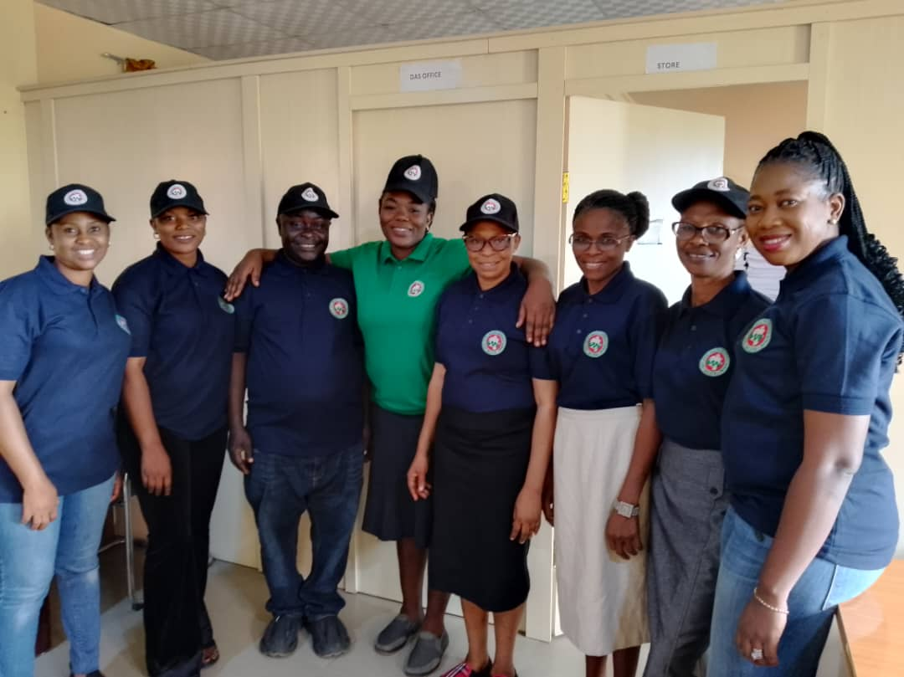
Department of Admin and Supplies Staff
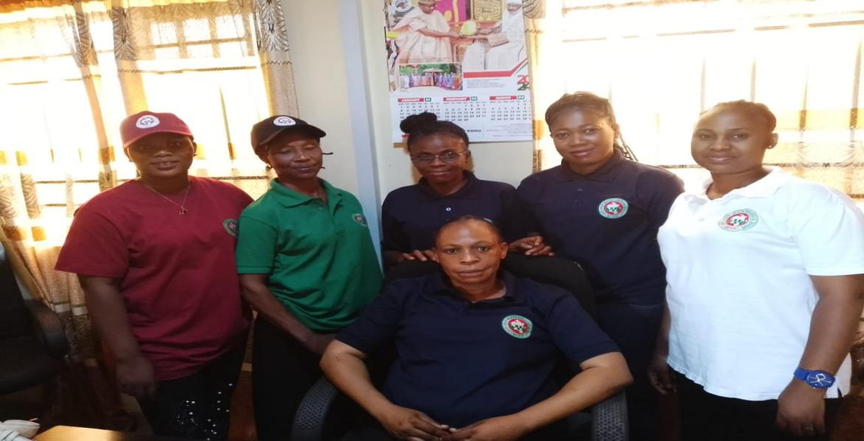
Department of Admin and Supplies, sitting down is the Director: Mrs. Adeyemo Grace
2.5 ICT Unit
Mrs. Gbemisola, AREGESOLA (Head)

2.5.1 INTRODUCTION
The department is responsible for all ICT related matters and provides supports services. Mandate: manage and operate IT functions for the scheme.

2.5.2 FUNCTIONS
- Responsible for overseeing all aspects of the ICT work
- Develop and management of BHCPF mobile app for capturing enrollees.
- Initiate and managing Ulerawa platform for the scheme
- Generating, sorting and printing out enrollee list to the facility on monthly basis.
- Maintenance of server and all ICT equipment.
2.5.3 IMPLEMENTATION STATUS FROM ICT DEPARTMENT
S/N | ACTIVITIES | STATUS
1 | Enrolment section should be created for the BHCPF as this is criteria to benefit from the program. | On-going
2 | Enrolment on the platform for the BHCPF and ULERAWA program should be printable for the use of facility | On-going  BHCPF
3 | BHCPF and ULERAWA section should be able to generate Authorization code and Claims management purposes for referral of enrollees | Done
4 | BHCPF section should be able to generate the utilization data for prompt management decision | Not done
5 | The app should be able to incorporate all other plans e.g formal sector, informal sector or community base | On -going
6 | It must have interface with Primary Health Centre Facilities for coordination purposes for utilization purpose | On-going
7 | It must be able to flag any double registration | Done
8 | It must be able to exist children above 5 years automatically (BHCPF) | Not- done
9 | Ensure easy referral Claims processing and vetting with easy payments. | Done
10 | Creating more username and password for the remaining facilities. | Done

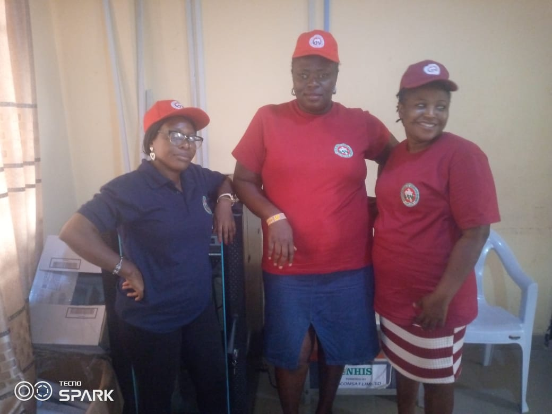
ICT Unit

2.6 Department of Finance and Account

Mr. Samuel, OLAOYE (Director)

Inflow and Outflow to EKHIS
S/N | SOURCE | INFLOWS | OUTFLOWS | BAL
1 | CAPITAL VOTE | 50,000,000.00 | 50,000,000.00 | -
2 | DRUGS MGT | 100,000,000.00 | - | 100,000,000.00
3 | EKSMOH&HS | 60,000,000.00 | 52,772,537.47 | 7,227,462.53
4 | RUNNING GRANT | 495,000.00 | 495,000.00 | -
5 | EKHIS COMMITTEE | 495,000.00 | 495,000.00 | -
6 | PERSONNEL COST | 22, 591,863.36 | 22, 591,863.36 | -
7 | BHCPF | 384,257,466.00 | 255,833,400.94 | 128,424,065.06
 | TOTAL | 535,247,466.00 | 359,595,938.41 | 235,651,527.59

SOURCE | AMOUNT | %
EKITI STATE GOVT | 133,581,863.36 | 22%
BHCPF | 384,257,466.00 | 62%
EKDAHSM | 100,000,000.00 | 16%
TOTAL | 617,839,329.36 | 100%
S/N | SOURCE | INFLOWS | OUTFLOWS | BALANCE
1 | STATE GOVT | 50,000,000 | 50,000,000.00 | -
2 | DRUGS MGT | 100,000,000 | - | 100,000,000.00
3 | EKSMOH&HS | 60, 000,000 | 52,772,537.47 | 7,227,462.53
 | TOTAL | 210,000,000 | 102,772,537.47 | 107,227,462.53
ULEREWA HEALTH INTERVENTION PROGRAMME
2.6.1 (INFLOWS AND OUTFLOWS OF FUND)
Expenditures on Ulerawa to cost centre
- Structure of expenditures
COST CENTRE | AMOUNT | %
CLAIMS PAYMENT | 59,706,101.00 | 58%
PRODUCTION OF TOOLS | 11,330,500.00 | 11%
TECHNICAL SUPPORT | 23,394,000.00 | 23%
OTHER PAYMENT | 8,341,936.47 | 8%
TOTAL | 102,772,537.47 | 100%

- BASIC HEALTH CARE PROVISION FUND
(JANUARY-DECEMBER 2023)
Breakdown of amount received and expensed:2023
Distribution Sub-Head | Amount Recived for the year | Actual Expenditure Jan-Dec 2023 | Balance as at  31/12/2023
Capitation (57%) | 219,026,755.62 | 148,500,960.00 | 70,525,795.62
Fee-For-Service (18.25%) | 70,126,987.55 | 25,528,983.78 | 44,598,003.77
Reserve Fund (5%) | 19,212,873.30 | - | 19,212,873.30
ICT Resources (7.25%) | 27,858,666.29 | 43,439,000.00 | (15,580,333.72)
Admin Fee (5%) | 19,212,873.30 | 15,708,557.16 | 3,504,316.14
SQA & M/E | 28,819,309.95 | 22,655,900.00 | 6,163,409.95
TOTAL | 384,257,466.00 | 255,833,400.94 | 128,424,065.06

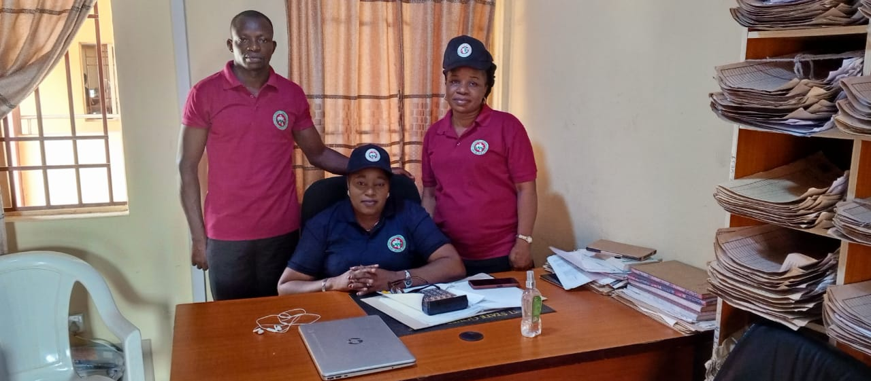
The Director Finance and Account, Mr. Samuel Olaoye(Standing Left) with other staff of the Department

03
2.7 Internal Audit
Mr. Akinola, ILESANMI (Auditor)

2.7.1 INTERNALLY GENERATED REVENUE
Ekiti State health insurance scheme is not a revenue generating entity for the state government.
2.7.2 CAPITAL EXPENDITURE
In the year 2023 the capital expenditure incurred by this Office from the budgetary provision of #600,000,000.00 with ISPAS CODE 052100100300 was #50,000,000.00 was released as capitalization for vulnerable group in Ekiti State with 8.33% of budgetary performance.
2.7.3 OVER HEAD
- From recurrent vote with ISPAS CODE 05210005210010000300, a sum of 495,000.00 was released as running grant to the Agency with balance of #5,000.00 out of budgeted sum of #500,000 for the year 2023 which is 99% of budgetary performance for EKHIS
- Also From recurrent vote with ISPAS CODE 05210005210010000300, a sum of 495,000.00 was released as running grant to the Agency with balance of #5,000.00 out of budgeted sum of #500,000 for the year 2023 which is 99% of budgetary performance for EKHIS

2.7.4 PERSONNEL:
TABLE:
HEAD | DETAILS | APPROVED ESTIMATE FOR 2023 # | ANNUAL SALARY FOR YEAR 2023 | APPROV-ED EST. BALANCE FOR YEAR2023 # | BUDGETARY PERFORMANCE
052100200100 | SALARY | 22,896,018.65 | 22,591,864 | 299,655.29 | 99%
Number of staff on Nominal Roll is 27.
Number of staff on Pay Roll is 22.

04

Plan：

06
Chapter Three: Special Events
3.1 SENSITIZATION ON ULERAWA AND BHCPF TO IDO/OSI LGA
on 4th August, 2023
The exercise took place at the palace of Olujudo, Ido Ekiti on Friday 4th August, 2023
The HCH &HS highlighted the services that are free to the community as follows:
- Maternal and child health care
- Malaria
- Family planning
- Nutrition and
- Other services
The event was graced by important personnel which include:
The Olujudo of Ido Ekiti which is also the Chairman Council of Obas in Ekiti State, Owalogbo of Ilogbo Ekiti, Olugbole of Igbole Ekiti, The Chairman Ido/Osi LGA, General Manager, EKHIS, Executive Secretary, SPHCDA and other necessary stakeholders.
The sensitization visit also featured medical outreach where residents of Ido/Osi LGA and its environs were registered and attended to on their various health needs.

The HCH&HS Dr. Oyebanji Filani addressing the public at Ido Ekiti
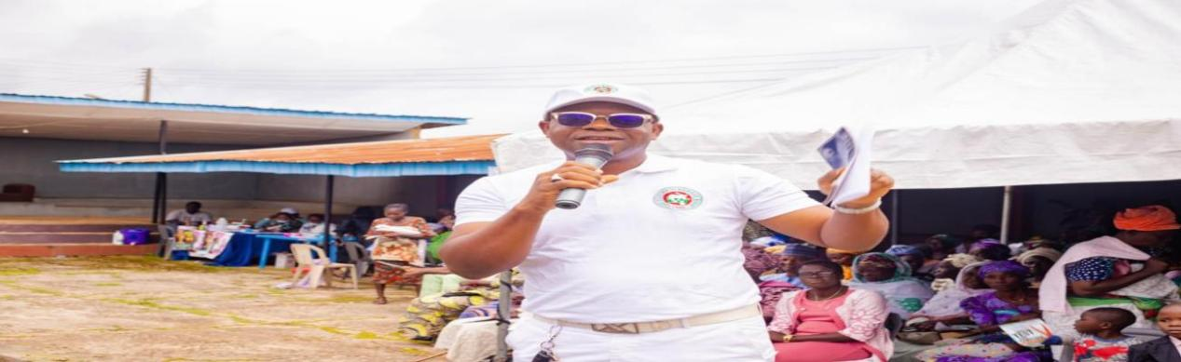
The GM, EKHIS sensitizing the public on BHCPF & ULERAWA at Olujudo’s palace
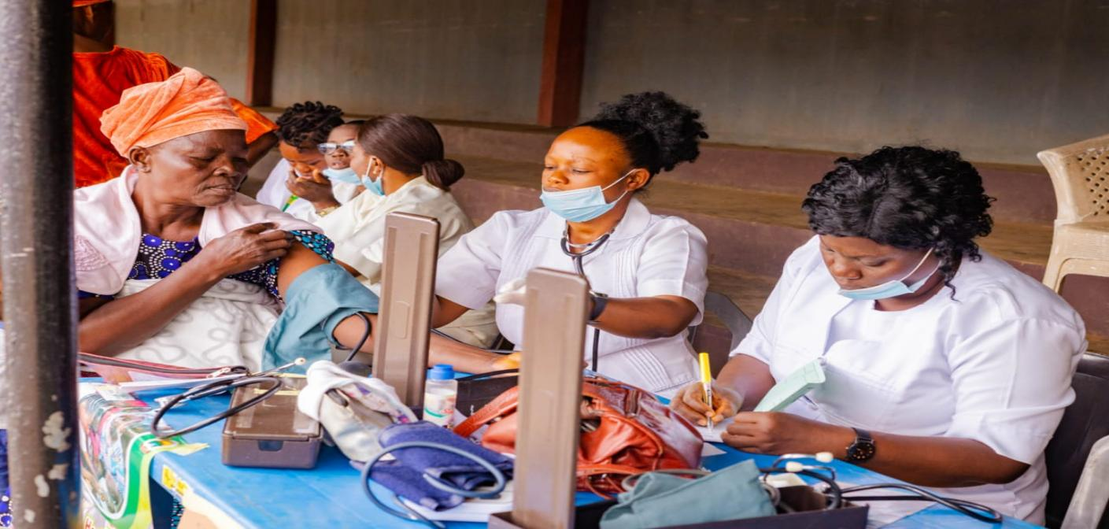
Health workers attending to clients @Ido Ekiti medical outreach
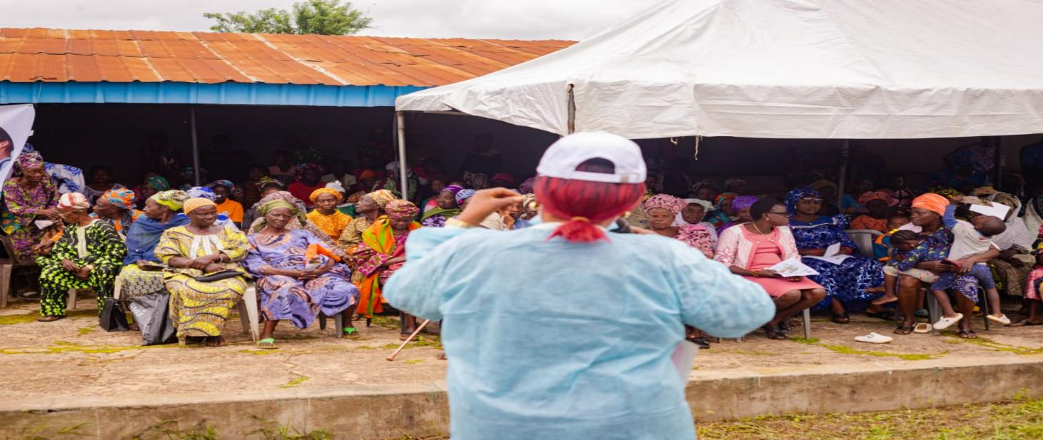
Health worker sensitizing the congregation at the medical outreach service in Ido- Ekiti

3.2 SENSITIZATION ON ULERAWA AND BHCPF TO ISE/ORUN LGA
on August 24th, 2023 @Arijale’s palace Ise- Ekiti
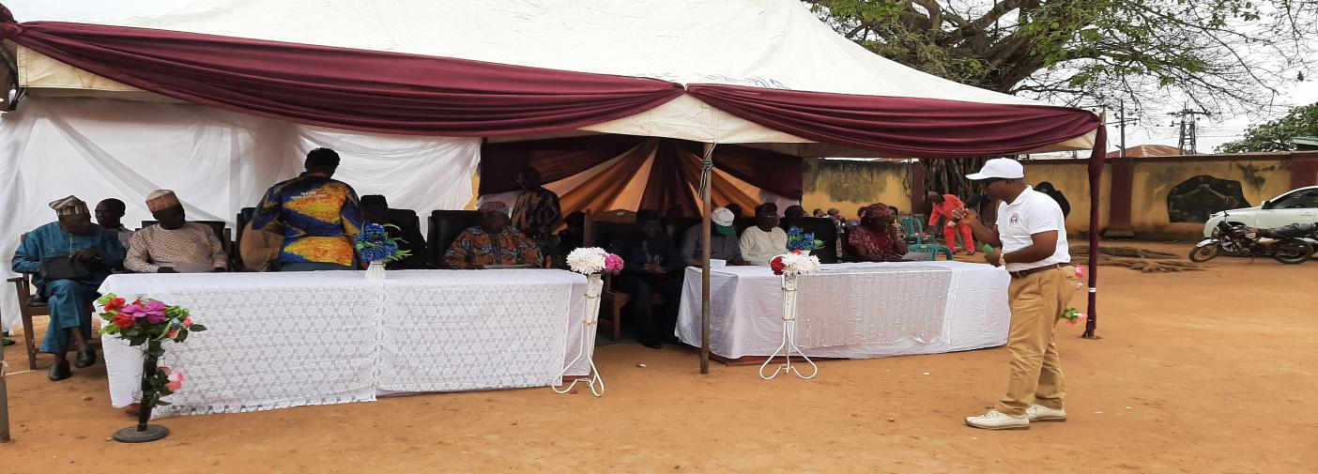
The GM, EKHIS addressing the public at Arinjale’s palace, Ise- Ekiti
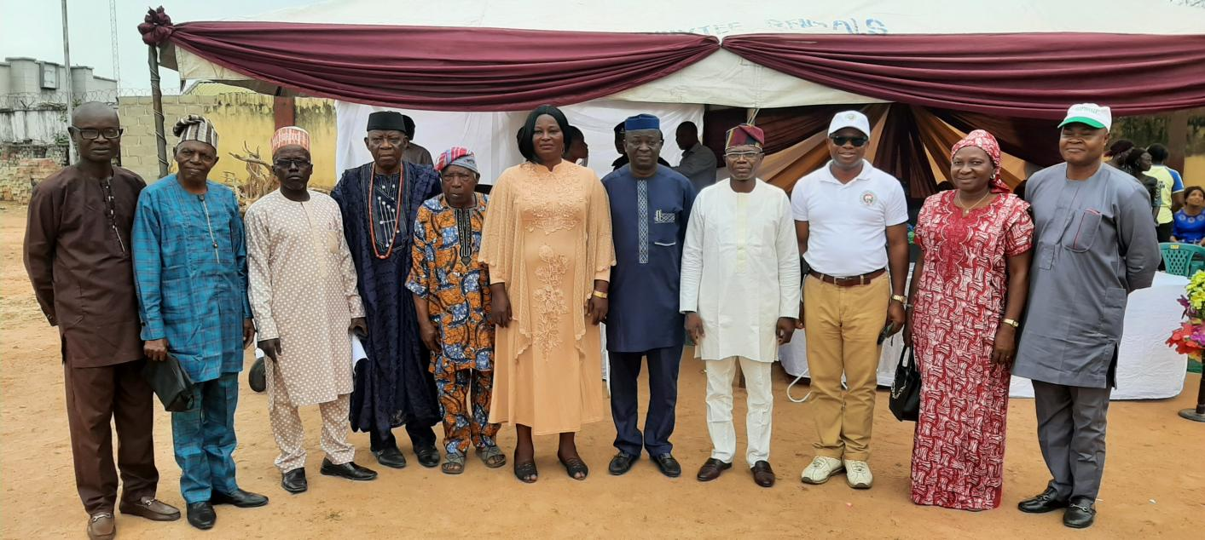
Cross-section of important dignatories at the Medical Outreach in Ise- Ekit
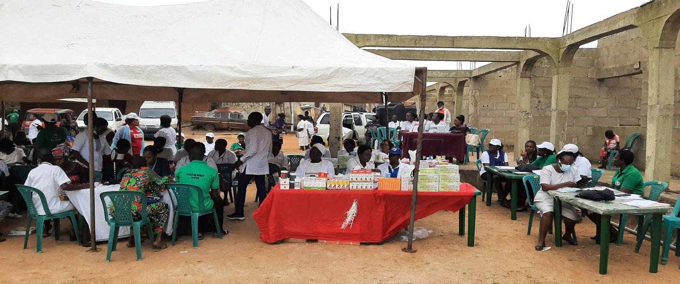
Health workers giving servives at the medical outreach in Ise- Ekiti
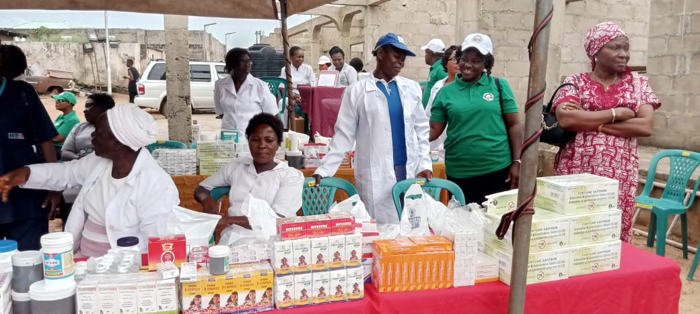Pharmacy unit at the free medical outreach in Ise Ekiti

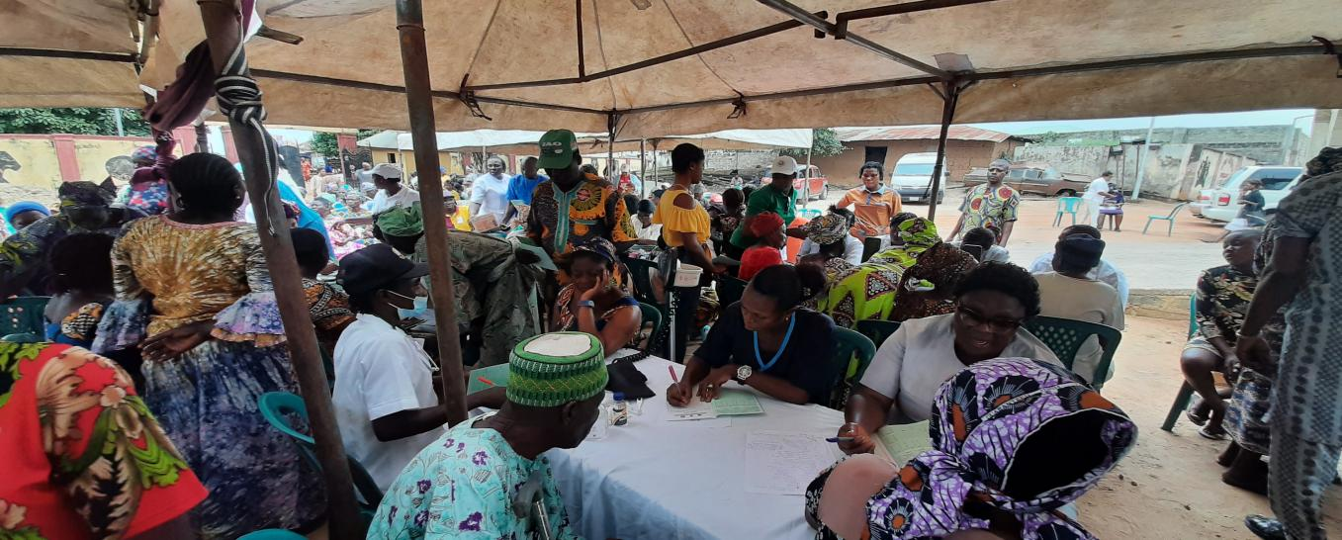
Free medical Outreach at Ise Ekiti
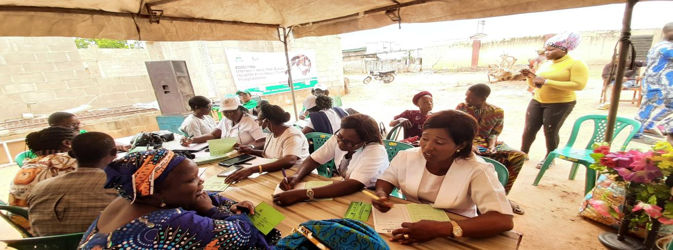
Record unit at the free medical outreach at Ise- Ekiti

3.3 SENSITIZATION ON ULERAWA AND BHCPF TO IKOLE AND OYE LGAs on 15TH SEPTEMBER, 2023 @STATE SPECIALIST HOSPITAL IKOLE AND OLOYE’S PALACE, OYE
The BHCPF and ULERAWA programs wish to improve health care service deliveries in Ekiti State. The programs are targeting over 1,000,000 lives in Ekiti State as this will enable the State to achieve UHC.
In view of the above, the State team led by the HCH&HS embarked on a sensitization and medical outreach to the people of Ikole and Oye LGAs of the State.
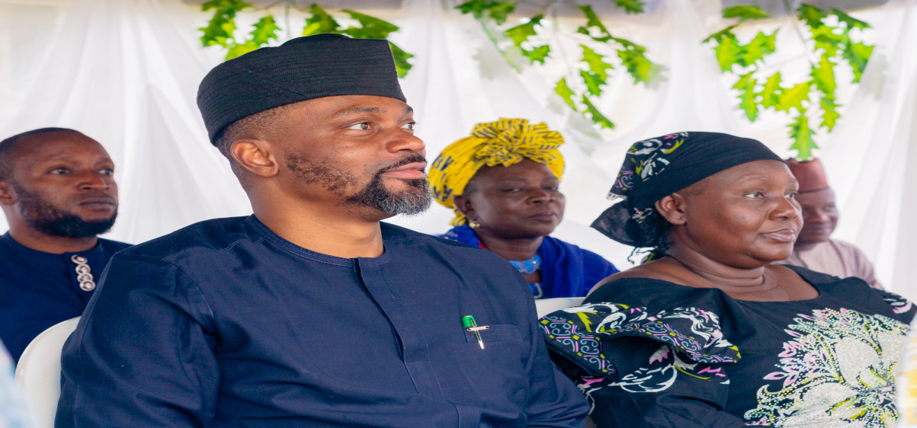
The HCH&HS( Dr. Oyebanji Filina) and The PS, MOH&HS (Mrs Olushola Gbenga-Igotun) at free medical outreach in Ikole Ekiti

The HCH&HS in a group photograph with the Oloye in council at the free medical outreach in Oye Ekiti
.
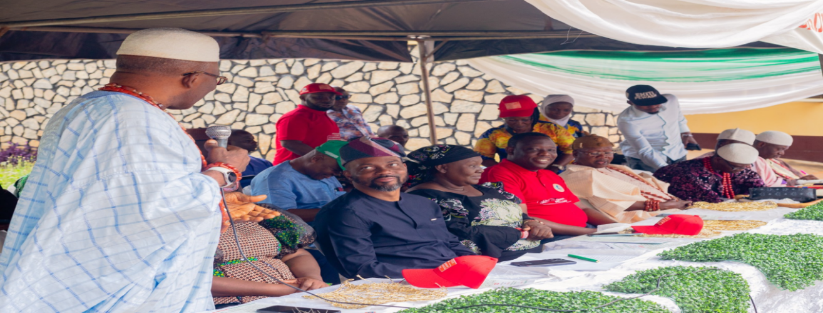
Cross- section of important dignitaries at the free medical outreach at Ikole Ekiti


The HCH&HS, MOH&HS(right) and the GM, EKHIS (left) @ Ikole Ekiti

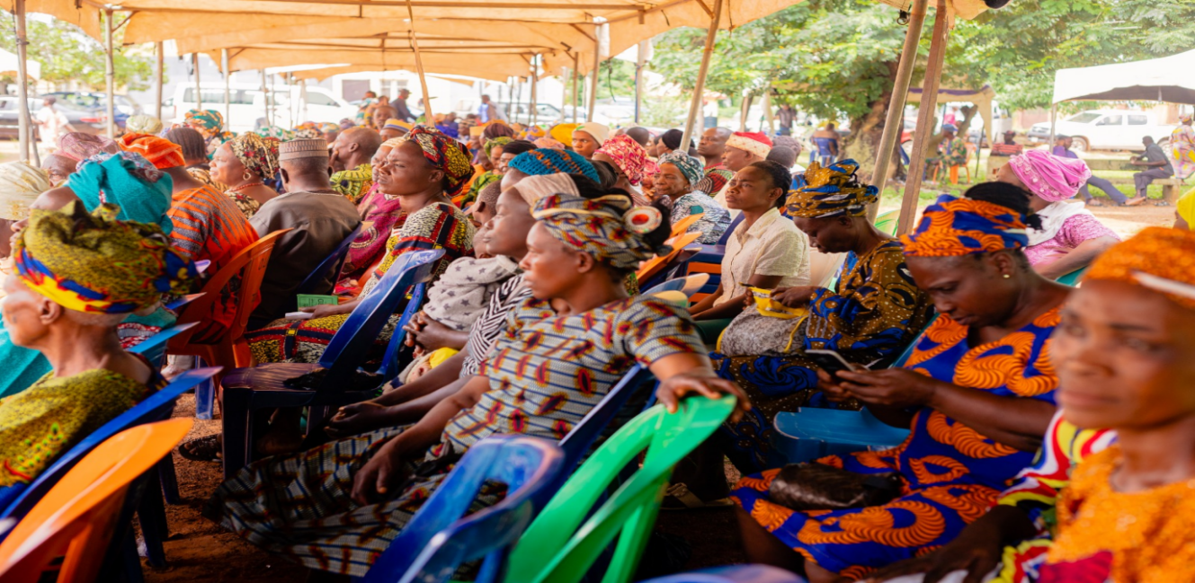
A scene at free medical outreach at Ikole Ekiti

Plan：

3.4 DISTRIBUTION OF TABLETS TO HEALTH FACILITIES FOR ULERAWA PROGRAM
In 2022, the Ekiti State Health Insurance Scheme (ESHIS) commenced the Ulerawa program on a pilot basis, launching in 25 facilities across 5 Local Government Areas (LGA) in our state. To ensure an evidence informed approach to program improvement, the Ekiti State Health Insurance Agency, engaged the services of a technical partner, Devstork Platform for Development (DPD), Ltd, to support the Scheme in expanding the scope of services to all the 177 facilities in the State.
The Scheme had scaled up the services of the program to all the accredited 177 facilities in Ekiti State and enrollees have started accessing care in these expanded facilities. In order to boast the operation of the program in these facilities, the scheme presented Tablets to 50 facilities in the review year.

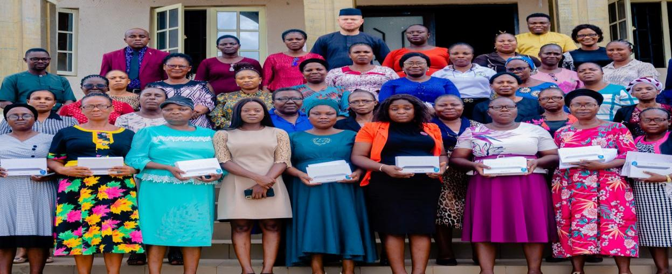
Group picture of the presentation of tablets to health facilities
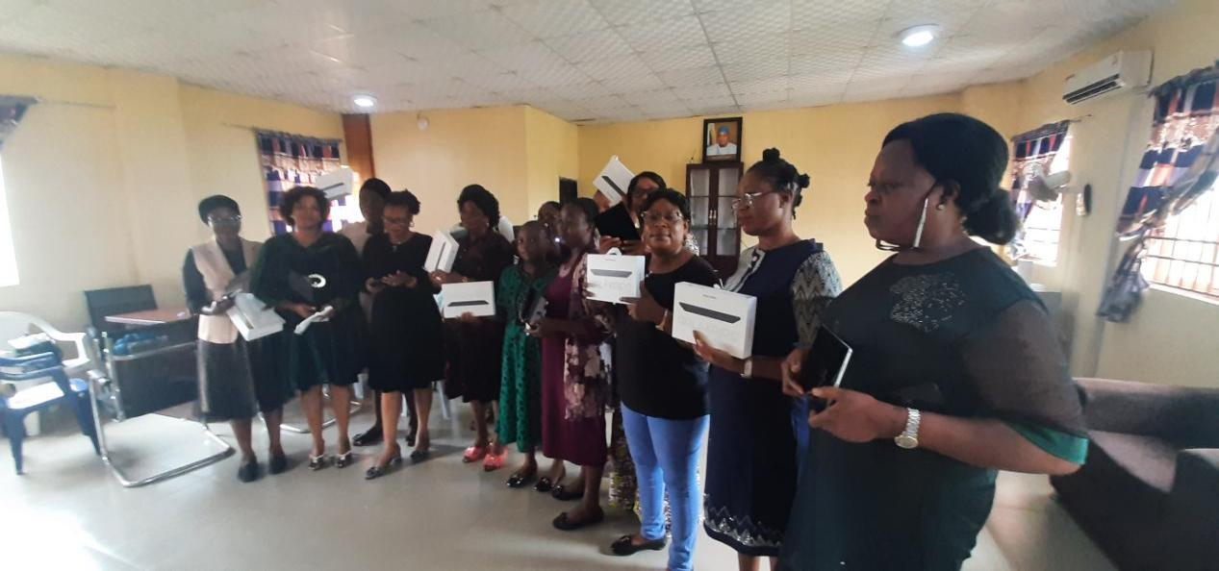
Presentation of tablets to ULERAWA facilities @ EKHIS office

3.5 CAPACITY BUILDING
The Agency participated in various capacity building in the agency which include: Gender Mainstreaming, leadership development, stakeholder Engagement and Team Management, Future of Health System Program for Leaders and Financial Management.

Group discussion during the gender mainstreaming’s training

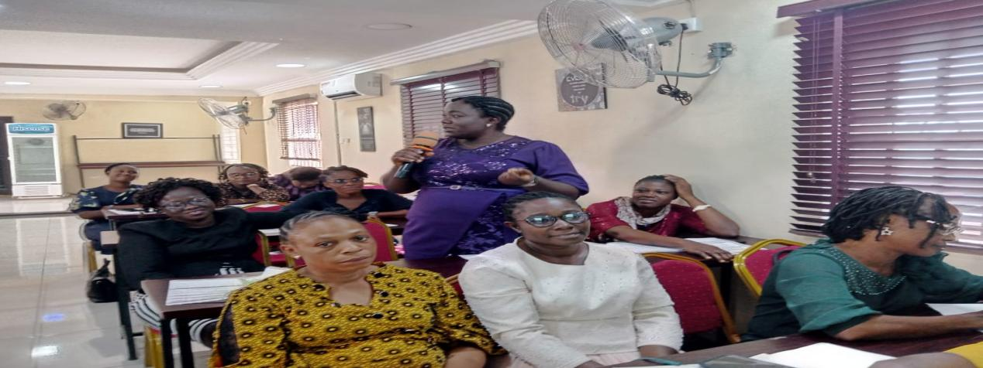
A scene at a training organized by CHAI

Group discussion at a training

3.6 MONITORING AND EVALUATION

One of the most effective ways of measuring the quality of care given to enrollee at the various health facilities is through thorough Monitoring and Evaluation and mentorship at the facility level.
The BHCPF guideline provided that Standard Quality Assessment should be carried out in all the accredited facilities in a calender year and the Scheme had already conducted SQA in 50% of its facilities and must visit the remaining 50% of the accredited facilities for proper supervision.
Prior to the above, the Scheme conducted SQA/ M&E/ Sensitization/ Audit exercise to the 16 LGAs across the state.

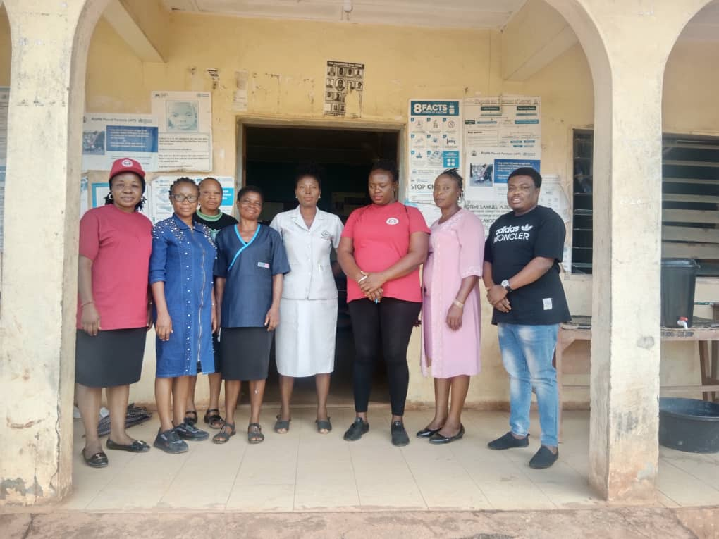
M&E exercise at Ekiti East LGA

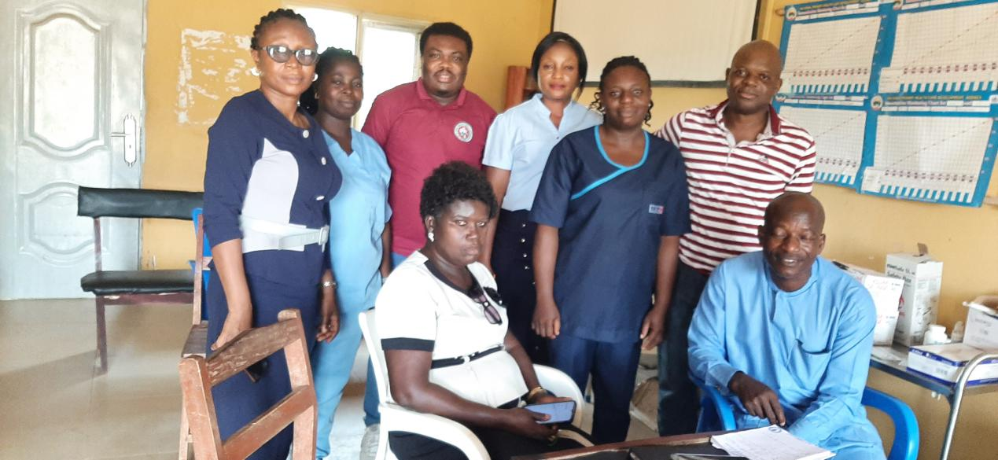
EKHIS Team at CHC KOTA in Ekiti East for M&E/SQA exercise

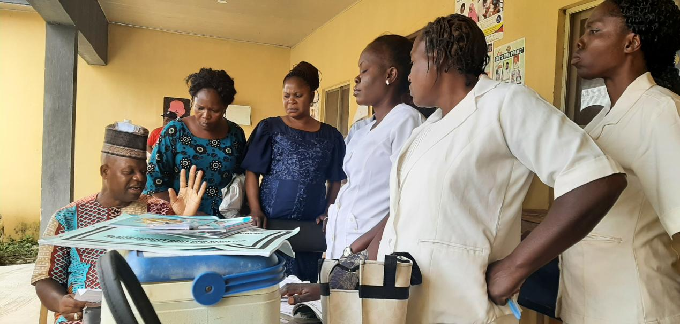
The GM,EKHIS addressing the Health workers during the M&E exercise

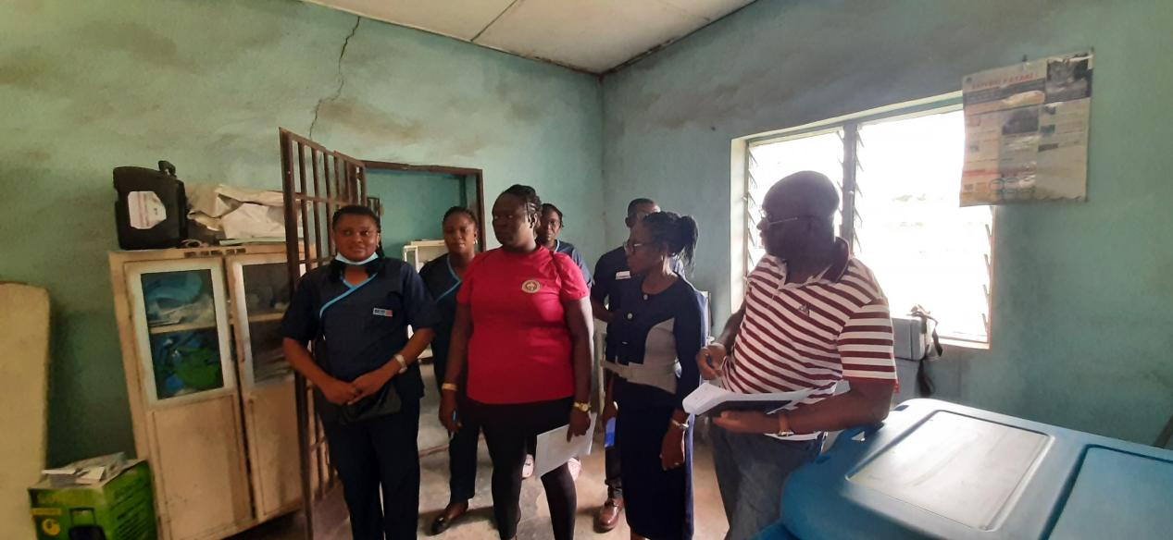
EKHIS Team during M&E/SQA visit to BHC Ilasa Ekiti

The Hon. Commissioner for Health and Human Services Hosted Mrs. Olanike Ojo, The Officer in Charge of Okeruku Health Post Ikere- Ekiti in recognition of her Excellent efforts and performance at promoting ULERAWA and BHCPF programs in her facility (20th September, 2023)




Enter target title

3.7 Advocacy Visits

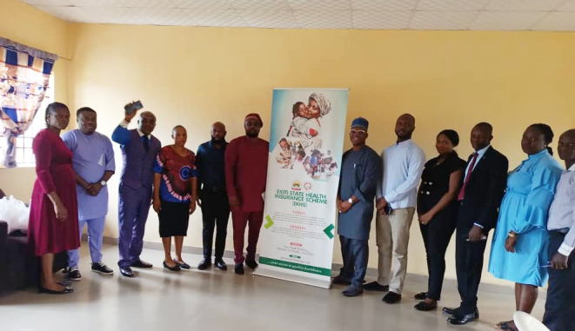

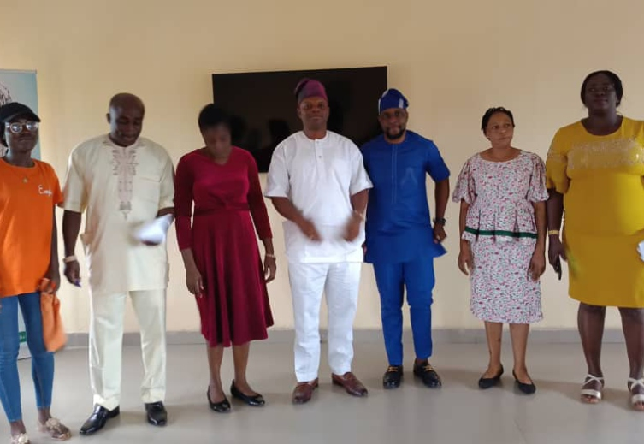

Advocacy visit by Olanipekun Ayomide (O.A) initiative
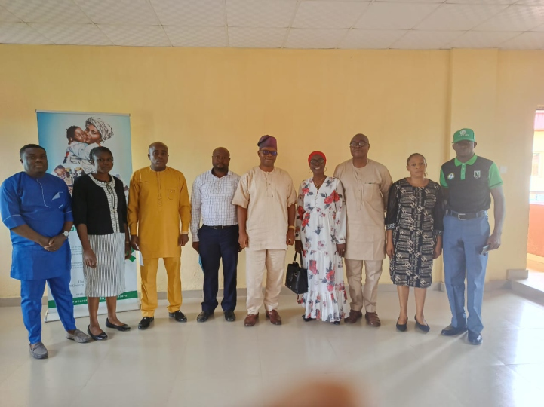

Advocacy visits by National Health Insurance Authority

Advocacy visits by Clinton Health Access Initiative

4.0 CHAPTER FOUR: BHCPF and ULERAWA programmes
The Basic Health Care Provision Fund (BHCPF or “The Fund”) was established under Section 11 of the Act, as the principal funding vehicle for the BMPHS, whilst at the same time, serving to increase the fiscal space and overall financing to the health sector. It is expected that the attendant service upscale arising from application of this funding, would assist Nigeria achieve UHC.
The purpose of the BHCPF is threefold: (1) Ensuring the provision of a Basic Minimum Package of Health Services to all Nigerians, by applying 50% of the funds towards purchase of the BMPHS to be managed by the National Health Insurance Scheme (NHIS); (2) Strengthening the Primary Health Care (PHC) system - With 45% of BHCPF, to be disbursed by the National Primary Health Care Development Agency (NPHCDA) for the provision of essential drugs, vaccines and consumables for eligible primary health care facilities (i.e. 20% of BHCPF), the provision and maintenance of facilities, laboratory, equipment and transport for eligible primary healthcare facilities (15% of BHCPF) and the development of Human Resources for Primary Health Care (10% of BHCPF); and (3) Providing Emergency Medical Treatment - with 5% of the BHCPF to be administered by the National Emergency Medical Treatment Committee (NEMTC) as appointed by the National Council on Health (NCH)
To further improve access to care, the state government flagged off ULERAWA program under the management of EKHIS which started in selected 25 facilities in July 2022 across 5 LGAs and have now expanded to all the accredited facilities in the state. The program has a goal of covering 1,000,000 lives by year 2027.
The Ulerawa program a ‘case bundled system’ was designed to provide universal health coverage to residents of Ekiti State, with a particular focus on ensuring that the most vulnerable members of the population have access to quality health care services. Ulerawa aims to scale up access to a comprehensive package of high impact primary care package.
ULERAWA program focuses on providing reimbursement to health facilities based on the delivery of a suite of high impact health interventions that addresses 73% of the disease burden in the State. The program has the following priorities:
1. Improving access to quality and affordable health care through Ulerawa
2. Universal health care through primary health care facilities.
3. Strengthening the State’s public health response.
The BHCPF enrolled 24, 945 lives in year 2023 and provided 76, 886 services which include malaria, ANC, immunization, referral services to the citizens of Ekiti State.
The ULERAWA program covered 114,315 services where malaria was 37% of services provided and 71% were female. Ekiti State Health Insurance Scheme provided 191,201 services to the Ekiti State population in the year 2023.
4.1 Data Analysis:

----------
----------
----------
----------
----------
----------

----------
----------
----------
----------
----------
----------
Source: EKHIS ULERAWA Platform

Chapter five: from the Partners


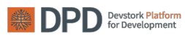
Dr. Chukwuemeka Azubuike

5.1 Activities of DPD as TA partner
In scaling up “Ulerawa” across the state, the Ekiti State Health Insurance Agency, engaged the services of DPD to support the state with assessing its pilot implementation, identifying gaps and areas for improvement, and designing an implementation plan to scale up the scheme across the 16 LGAs. Specifically, DPD
was charged to;
- Provide Technical support to the State Health Insurance scheme to better understand and address the gaps affecting access to and provision of quality of care Support the EKHIS team to train and build capacity of health providers and the Ulerawa Support team to better perform their roles and functions
- Support the Ulerawa program in developing process documentation, performance matrices, standard operating procedures and other critical systems that assure smooth operations of the program.
5.2 Key operational activities, achievements and outcomes ] 2023
5.2.1 Pre-implementation phase
We commenced pre-implementation in April 2023 with baseline assessments to understand the Ulerawa process and the development of an implementation handbook.
5.2.1.1 Implementation handbook: The implementation handbook serves as a comprehensive framework, outlining the strategies and measures for effective implementation of Ulerawa. It encompasses key elements such as community mobilization, effective service delivery, seamless claims management, prompt payment, quality assurance and demand generation. The document offers strategic guidance for driving program success and quality healthcare access. The manual also highlights key roles of Ulerawa stakeholders as well as suggested new roles that would contribute efficiently to Ulerawa outcomes.
5.2.1.2 Training of NYSC Corp members: We worked with the EKHIS team to train 8 NYSC Corp members on the Ulerawa handbook. We trained them on theoretical aspects of Ulerawa- Community mobilization, service delivery, quality of care as well as practical sessions on the Use of the ICT platform for claims vetting. We also selected 7 members (6 Claims, 1 Complaints handling).
5.2.1.3 Training of health workers: We worked with the EKHIS team to conduct practical state-led training sessions for 177 OICs, 177 M&E officers and 16 LGA focal persons. Using a structured curriculum, health workers were trained on the Ulerawa activities, claims vetting and the use of technology. LGA focal persons were informed and trained on their additional roles in the #areas of data entry and mentorship. Community mobilizers were also involved in the training sessions.
5.2.3.4 Discussions with the EKHIS Directors: The discussion focused on the key implementation phase activities which include
o The need for step down training within a week in all facilities.
o Monthly community mobilization
o Monthly supportive supervision
o Monthly or quarterly LGA to LGA peer reviews.
o Roles and responsibilities of the directors
5.2.2 Implementation Phase
Full implementation kicked off in September 2023 and would run till Feb/March 2024 and executed key implementation activities: Community engagement, designed dashboards and trackers for monthly performance tracking, supportive supervision, complaint management leveraging the roles of EKHIA directors, NYSC corpers, health educators, LGA focal persons and facility OICs.
5.2.2.1 Claims vetting: Since the initiation of full implementation, our diligent vetting process has scrutinized a substantial total of 111,807 claims. Among these, an impressive sum of over 101,902 claims have been deemed eligible and consequently approved for further processing. These figures underscore our commitment to ensuring transparency and efficiency in the handling of claims, reflecting our dedication to responsible stewardship of resources allocated for the betterment of our community. Corpers were incentivize with data plans worth N10,000 and N10,000 as stipend on a monthly basis.
5.2.2.2 Complaints management: To streamline the reporting of complaints, we established a complaint management system whereby beneficiaries have the option to directly contact the EKHIS office to voice any grievances or difficulties encountered in accessing Ulerawa services. To enhance engagement, we assigned the complaint officer the responsibility of proactively contacting a specified number of patients daily. Over the period from September to December 2023, a total of 2279 outreach calls were conducted. The complaint handler was also incentivize with data plans worth N10,000 and N10,000 as stipend on a monthly basis.
5.2.2.3 Service delivery- Antenatal visits, under 5s treated and Childbirth (deliveries):
To gauge performance, we focused on monitoring service delivery within Maternal, Newborn, and Child Health (MNCH). This encompasses tracking the number of antenatal visits, treatments administered to children under the age of 5, and the total number of deliveries conducted. Since commencement of full implementation, a total of 18,517 patients have visited facilities for antenatal care across the Local Government Areas (LGAs). A total of 25,329 children under the age of Five have been administered treatment A total of 1676 childbirths have been recorded out across facilities within the LGAs. LGA focal persons were incentivize to collect and report service delivery data on a monthly basis.
5.2.2.4 Community Mobilization: For a 4- months trial run, at least 3 community outreaches were conducted in each LGA monthly by the LGA Health Educators. Initial sensitization took place in July 2023 and then routine mobilization using LGA community mobilizers ran from September to December 2023. We conducted 173 outreaches and reached a total of 32,391 people across the 16 LGAs.
5.2.2.5 Inter LGA performance assessment: In December 2023, we conducted an inter-LGA performance assessment and will leverage the results in implementing an inter-LGA mentorship initiative to foster peer-to peer accountability across LGAs. Using this system, high-performing LGAs mentor and support lower performing ones, fostering knowledge transfer and improved program outcomes. The peer-to-peer review system aims to leverage the expertise and success of the top 8 performing LGAs to mentor and support the lowest 8 performing LGAs. This collaborative effort aims to facilitate knowledge and skill transfer, fostering a conducive environment for mutual learning. The mentorship system is designed to improve overall effectiveness and outcomes within Ulerawa.
Performance indicators used to rank the LGAs include; Community visits, Claims rejected, Number of child birth deliveries, Number of under 5s treated, and Number of complaints.
- Top 8 Performing LGAs Sept, Oct 2023: Ikere, Ado, Irepodun/Ifelodun, Ido/Osi, Ekiti east, Moba, Ise/Orun and Oye.
- Lowest 8 Performing LGAs Sept, Oct 2023: Efon, Ilejemeje, Gbonyin, Ekiti South West, Ekiti West Ikole, Ijero and Emure
5.3 KEY CHALLENGES FACED IN 2023
- ICT: Ulerawa platform issues, as well as lack of program knowledge from some
facilities staff
- Staff shortage in some health facilities.
- Under reporting and high rate of data entry errors in some facilities.
- The programme is yet to cover other ailments like Hypertension etc. The program is also only limited to the vulnerable population.
5.4 ROAD MAP FOR 2024
1. Continuation of monthly evaluations of the Inter LGA Mentorship Scheme to gauge the performance of mentors and mentees, aiming for mentees to exceed their mentors' achievements/performance.
2. Continuous tracking monthly performance across various key operational activities.
3. Monthly tracking of total number of lives enrolled
4. Implementation of a comprehensive communication plan for Ulerawa platform
updates to relevant stakeholders

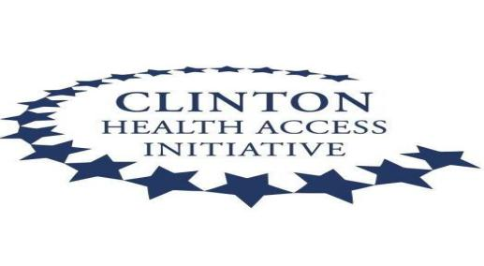
5.5. EXECUTIVE SUMMARY FOR 2023 CHAI EKITI ACTIVITIES
This project operations report summarizes the progress achieved in Year 2, from February to December 2023. It describes the progress achieved toward the outputs based on activities. The key project achievements between February and December 2023 include in February, the inauguration of the Project Steering Committee (PSC) and Project Implementation Team (PIT), the conduct of an assessment of the State health insurance agencies' (SHIAs) organizational capacity and information systems audit and the training of trainers on Gender mainstreaming. CHAI shared the findings from the organizational capacity assessment and the information systems audit with the EKHIS Management staff and co-created recommendations to address gaps identified. CHAI also conducted a VPP workshop with key National and State officials to define the funding, the number of beneficiaries, and enrollment processes for the vulnerable population program (VPP) initiative. The outcomes from these workshops have helped inform the development of a Memorandum of Understanding (MOU) between GAC/CHAI and the respective states on the VPP initiative. In line with ensuring a rights-based gender approach to program implementation. Also, an Information System Audit Dissemination meeting was done. In Q2 2023, CHAI conducted a dissemination meeting and shared findings from the assessment with the EKHIS. Additionally, the team co-developed recommendations that were categorized into short- and long-term goals across identified thematic areas. A key next step from the dissemination meeting was the development of a Business Requirement Document (BRD). BRD is a document detailing the requirements and step-by-step approach for the corresponding area of the Health Insurance Data Management System as it relates to Ekiti our program States Health Insurance Scheme.
In May 2023, CHAI conducted Gender Mainstreaming training in the states. The objective of the gender mainstreaming training includes the following: (a) To build the confidence, familiarity, and skills of SHIA staff to become knowledgeable on how to integrate gender equality and social inclusion (GESI) in health sector programs. (b) Problem-solving solutions to address gender-related barriers and issues in health that the government and civil society partners can address by integrating gender-sensitive transformative interventions in health care systems.
In order to acquire knowledge of best practices in the states and a better understanding of the successful implementation of the Health Insurance Scheme.
As part of CHAI deliverables on the project to strengthen Human Resource for Health. In the third quarter of 2023, CHAI conducted a vacancy analysis in the state. This analysis enables us to address staffing needs strategically and enhance service delivery. Following the conduct of the vacancy analysis, the team conducted a Root Cause Analysis workshop, which aimed to identify underlying issues to improve healthcare services effectively during the same quarter in the state. Also, the Root Cause Analysis was to examine factors that influenced gaps and vacancies across health facilities in Ekiti and help develop recommendations for activities to address the root causes.
In October 2023, following the engagement with the State Primary Health Care Agency (SPHCDA), the CHAI team identified a gap with respect to Quarterly Quality Assessment in 2023 as a result of a delay in the disbursement of funds to the agency by the National Primary Health Care Development Agency (NPHCDA), which informed CHAI to support the state in conducting Quarterly Quality Assessment across GAC facilities, ensuring the delivery of high-quality healthcare services.
We achieved a significant milestone by signing our MOU in December 2023, strengthening our partnership with the state, which is one of our major deliverable on the project. Additionally, the team worked with the SHIA to commence the enrollment process in the state. So far, the team have enrolled a total of 6350 beneficiaries with 21% (1334) pregnant women and 79% (5017) children under 5. This is a pivotal step in expanding access to essential healthcare services to the vulnerable population in the state

CHAPTER SIX:
6.0 2024 WORK PLAN
S/N | ACTIVITY | OBJECTIVE | OUTPUT
1 | Registration and payment of premium of Enrollees into the Equity health Programs | To achieve the State Universal Health Care Program | Financial protection and access to quality and affordable healthcare services for all residents of Ekiti State
2 | Advocacy, Sensitization and Mobilization | To improve knowledge on Health Insurance Scheme | Smooth implementation and operation of the scheme
3 | Production of Operational Guidelines, EKHIS law, ULERAWA implementation handbook, HMIS tools to relevant stakeholders. | To strengthen the EKHIS operation | Smooth implementation and operation of the scheme
4 | Monitoring and Evaluation | To measure the quality of service delivery | Improvement on the quality of service delivery
5 | Renewer, subscription and maintenance of ICT Infrastructure | To strengthen the EKHIS operation and measure the quality of service | Effective and Efficient Service delivery to health care providers via prompt reimbursement of claims
6 | Capacity Building | To strengthen the EKHIS operation | Improvement on the quality of service delivery
7 | Communication & Data | To provide technical, material and financial support to strengthen monitoring and evaluation | Guaranteed purchase of BMPHS
8 | Data Quality Assessment | To understand to what extent patients utilized the state-led insurance program | Improvement on the productivity and quality of service delivery
9 | Implementation of formal and informal health plan | To achieve the State Universal Health Care Program | Financial protection and access to quality and affordable healthcare services for all residents of Ekiti State
CHAPTER SEVEN: ACHIEVEMENTS SUMMARY, CHALLENGES AND CONCLUSION

7.1 Achievements

- The Ekiti State Health Insurance Scheme captured vulnerable populations (Pregnant Women, CU5, People Living With Disabilities, People Living with HIV, Elderly(above age 65years), Sickle Cell Warriors, Poor, Children of Orphanage homes, widows, Students of Special Schools) into the BHCPF in 175 accredited facilities in the state.
- Engagement of Technical partner to support the expansion of ULERAWA program
- The scheme expanded operations of ULERAWA programme from 25 facilities to 177 facilities across the 16 LGAs in the state
- Provision of 191,201 services to beneficiaries under health insurance programs across all the 16 LGAs in the state.
- Conducted SQA/M&E to all the 16 LGAs in the state to measure their performances
- Development of ULERAWA operational handbook to aid smooth implementation of the program
- Production and distribution of newsletter to necessary stakeholders to improve their knowledge and update them on health insurance programs
- Distribution phones and tablets to health facilities across the 16 LGAs for smooth implementation of ULERAWA program in Ekiti State
- Conducted Sensitization and outreach services to Ido/Osi, Ise/Orun, Oye and Ikole LGAs to increase the coverage of the EKHIS programs.
- Referred 470 patients for secondary services from the accredited primary facilities.
- Training of OICs and record officers, focal persons, ACED, M&E officers, H/Edu. at PHCs level and CMDs and DNS of secondary facilities on the implementation of the ULERAWA program
- Provision of ICT platform to all the 177 accredited facilities in the state
- Conducted consultative meetings with necessary stakeholders for smooth and better implementation of Health Insurance Programs.

7.2 Challenges
- Lack of project vehicle
- The ULERAWA program is yet to cover other ailments like Diabetes, Hypertension etc
- Ulerawa is yet to render secondary services in case of referral.
- Shortage of staff at the Health facilities
- Shortage of technical staff at the Health Insurance Scheme
- Insufficient office accommodation
- Under reporting of claims in some facilities
- Co-payments of BHCPF services in some health facilities
7.3 Conclusion
We discovered that the major hindrance to non-utilization of government health facilities was the financial barrier among the citizens. The ULERAWA health intervention of the Ekiti State Government through the Ekiti State Health Insurance Scheme will ensure that all residents of Ekiti state has access to quality health care services and protect them from financial hardship of huge medical bills.
There is no doubt that the Social Health Insurance Scheme is desirable as it is one of the best approaches to health financing globally. Its gives citizens access to quality and affordable health care services

